# Exercise: Git and GitHub

Problems for exercises and homework for the ["Software Technologies" course @ SoftUni](https://softuni.bg/trainings/4086/software-technologies-may-2023).

## Register a GitHub Profile

Register for a free **developer account at GitHub**: <http://github.com>/

Add a screenshot to my profile here:

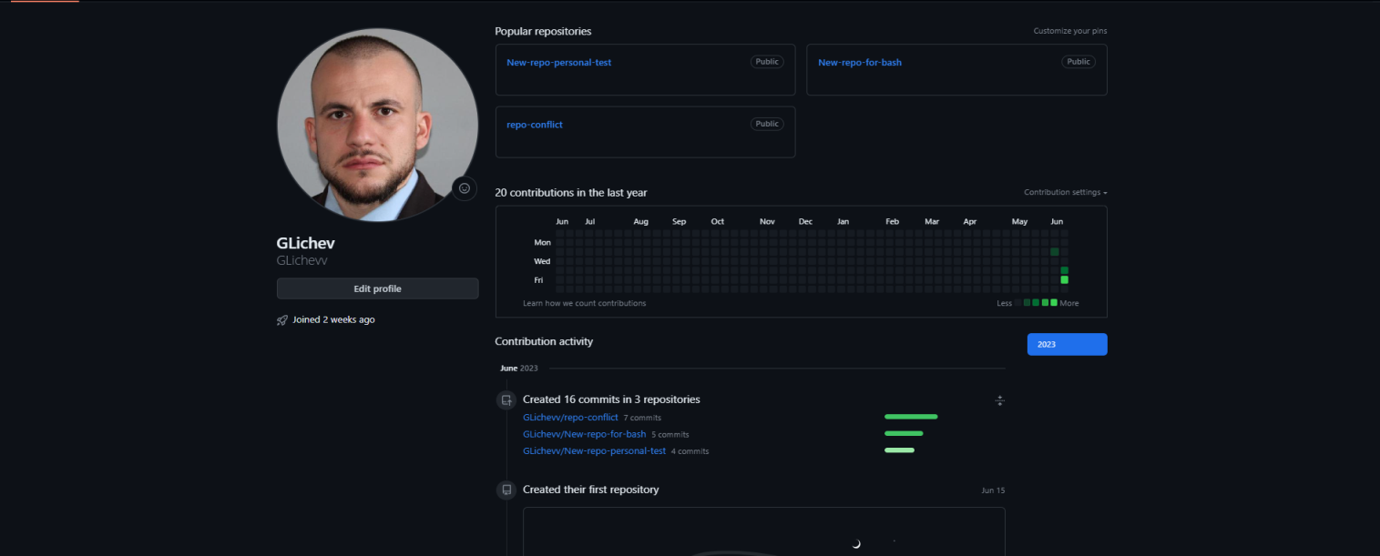

## Clone a Repo

Navigate to <https://github.com/SoftUni>. Find a repo that I like. Clone the repo that I choice in my profile.

In relation to the second task of the homework.

During Mr. Angel Georgiev's lecture, he explained that the second task actually involves forking a specific repository, which we choose from https://github.com/SoftUni, and that's why I have made a fork."

Provide a picture of the cloned repo here:



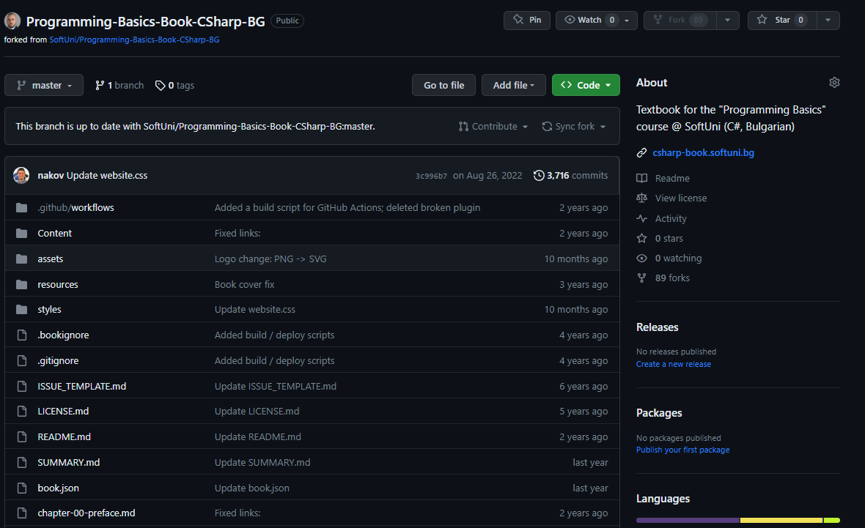

## Download a local copy of the repo to your computer

Using GitBash or GitHub Desktop, download a local copy of the repo to my computer.

After multiple attempts to **clone my repository**, I encountered the same **error** every time. The **error message** was **'Filename too long**.' After a quick search for a solution on Google, I managed to fix it. I started GitBash as an administrator and entered the following command: **'git config --system core.longpaths true**.' After that, the cloning process was successful. As a result, there is a screenshot showing the entered command."

Add a picture of the folder here:

